1. **Simulating skill of chlorophyll-a compared with remote sensing data:**

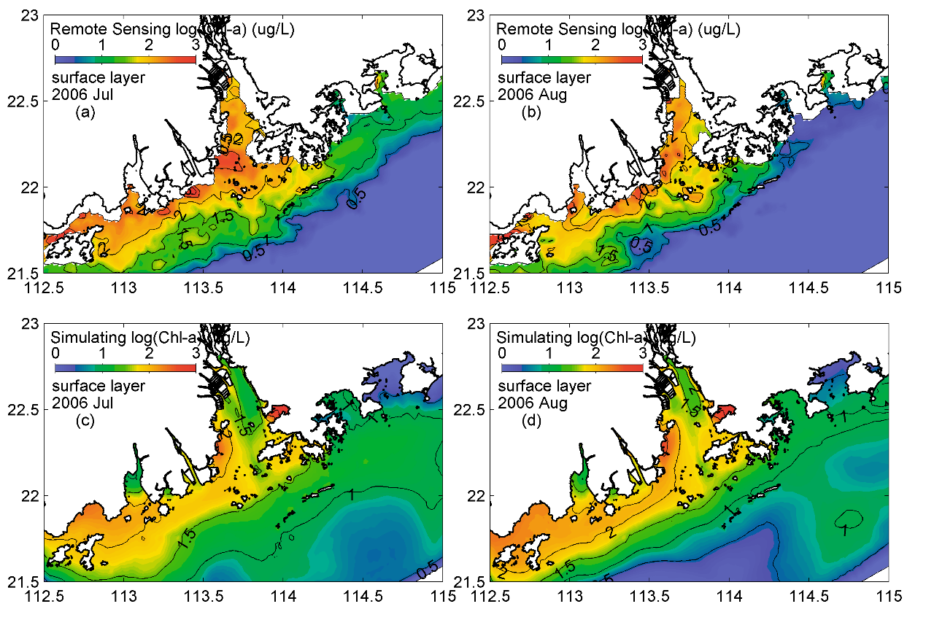

**Supporting Information Figure 1.** Horizontal distribution of remote sensing (upper panels) and simulated (down panels) Chl-a in July and August of 2006. (remote sensing data source: http://data.ceda.ac.uk/neodc/esacci/ocean_colour/data/v2release/geographic/netcdf/chlor_a/monthly/v2.0/2006/)

1. **Simulating skill of POC compared with remote sensing data:**

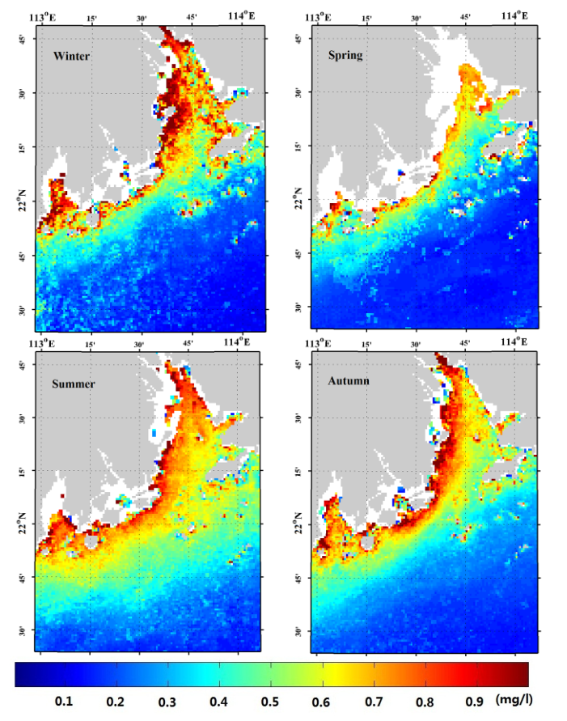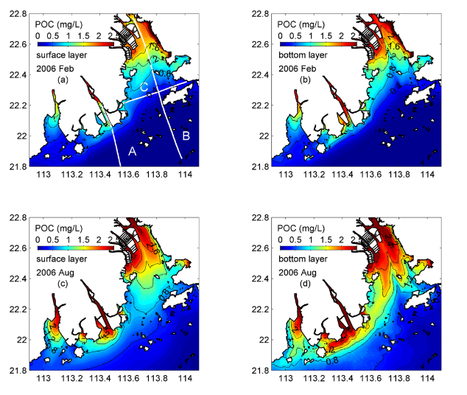

**Supporting Information Figure 2.** Horizontal distribution of four season remote sensing (1st and 2nd panels) and simulated (3rd and 4th panels) POC. Remote sensing data is supplied by Liu et al. (2015): Seasonal POC concentrations (mg/L) derived from the MODIS/AQUA data from 2002 to 2014 using the proposed algorithm. Each season is represented by a specific month: January for winter, April for spring, July for summer, and November for autumn (Liu et al., 2015).

1. **Simulating POC peak at middle layer:**

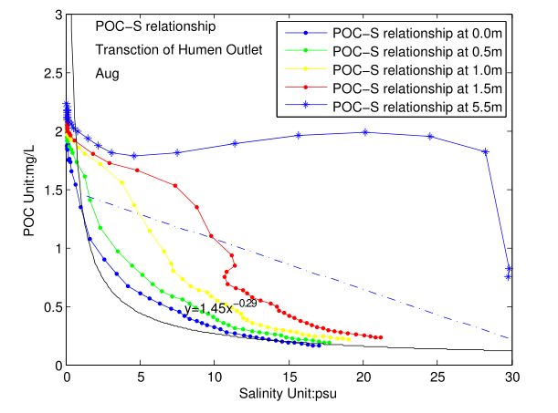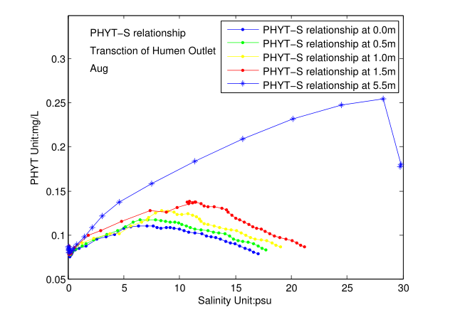

**Supporting Information Figure 3.** August POC-Salinity (a) and Phytoplankton-Salinity (b) relationship at different water depth simulated by carbon cycle model at Transection B as shown in the manuscript Figure 1.

1. Simulating nitrification rate compared with previous estimating

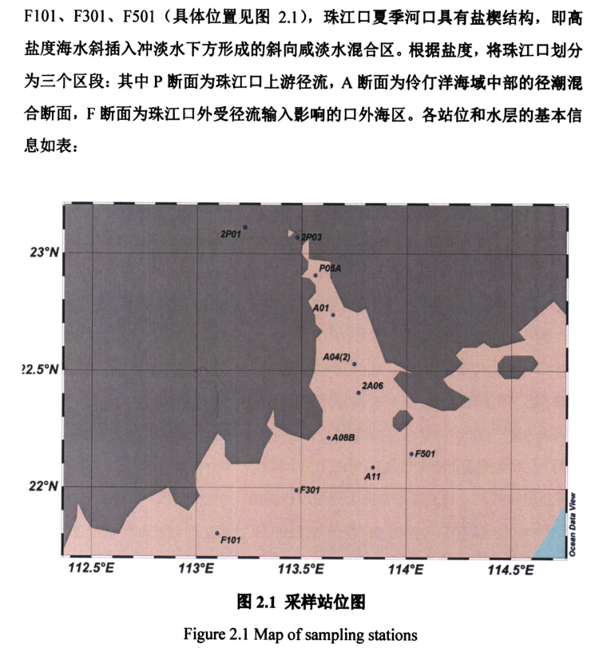

**Supporting Information** Figure 4: Map of sampling station in Zhang et al. (2016) for nitrification rate in PRE.

**Supporting Information** Table 1: Simulated nitrification rate at the corresponding sampling station

|  |  |  |  |  |  |  |  |
| --- | --- | --- | --- | --- | --- | --- | --- |
| **Upper and middle Lingdingyang bay** | | | | **Outer Lingdingyang bay** | | | |
|  | **Surface** | **Middle** | **Bottom** |  | **Surface** | **Middle** | **Bottom** |
| **A01** | 0.62 | 0.65 | 0.83 | **A11** | 0.33 | 0.11 | 0.13 |
| **A04(2)** | 0.67 | 0.71 | 0.87 | **F101** | 0.13 | 0.03 | 0.06 |
| **2A06** | 0.54 | 0.50 | 0.64 | **F301** | 0.21 | 0.07 | 0.15 |
| **A08B** | 0.33 | 0.30 | 0.46 | **F501** | 0.50 | 0.13 | 0.12 |

1. Simulating DOC consumption rate compared with previous estimating

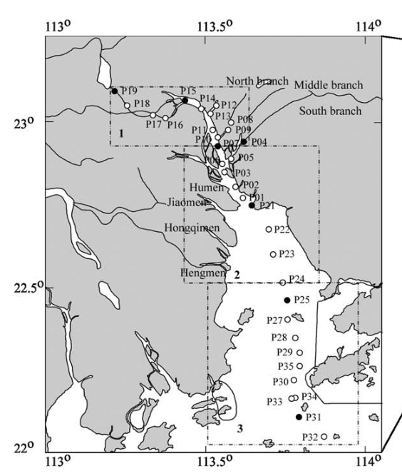

**Supporting Information** Figure 5: Map of sampling station in He et al. (2010) for DOC consumption rates in PRE.

**Supporting Information Table 2:** DOC consumption rates **comparison between simulation and estimation.**

|  |  |  |  |  |  |
| --- | --- | --- | --- | --- | --- |
| **Upper Lingdingyang bay** | | | **Midele and outer Lingdingyang bay** | | |
|  | **Estimate a** | **Simulate** |  | **Estimate a** | **Simulate** |
| **P21** | 0.12 | 0.15~0.16 | **P25** | 0.04 | 0.25~0.27 |
| **P22** | n.d. | 0.16 | **P31** | 0.04 | 0.03~0.05 |
|  |  |  | **P32** | n.d. | 0.03~0.04 |

a He et al. (2010).

**Supporting Information** **Table 3**: Simulated DOC consumption rates at the corresponding sampling station.

|  |  |  |  |  |  |  |  |
| --- | --- | --- | --- | --- | --- | --- | --- |
| **Upper Lingdingyang bay** | | | | **Midele and outer Lingdingyang bay** | | | |
|  | **Surface** | **Middle** | **Bottom** |  | **Surface** | **Middle** | **Bottom** |
| **P21** | 0.15 | 0.16 | 0.16 | **P25** | 0.27 | 0.26 | 0.25 |
| **P22** | 0.16 | 0.16 | 0.16 | **P31** | 0.05 | 0.03 | 0.03 |
|  |  |  |  | **P32** | 0.04 | 0.03 | 0.03 |

1. Simulating DOC concentration in pore water compared with previous estimating

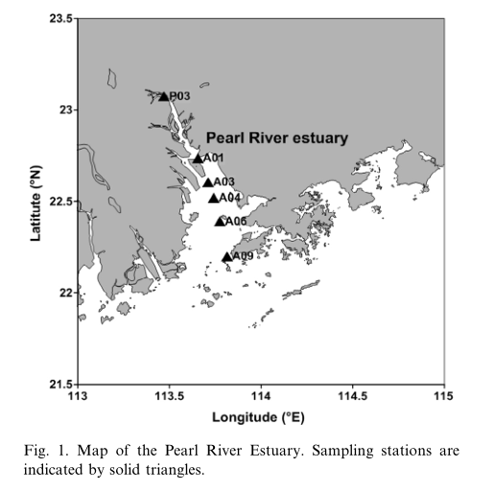

**Supporting Information Figure 6:** Map of sampling station in Cai et al. (2015) for DIC concentration in pore water and overlying water of PRE.

**Supporting Information Table 3:** Simulated DIC concentration in pore water and overlying water at the corresponding sampling station at November 16th -27th .

|  |  |  |  |  |  |  |
| --- | --- | --- | --- | --- | --- | --- |
|  | **Estimate a** | | | **Simulate** | | |
|  | **Bottom water** | **0-1 cm** | **5-10 cm** | **Overlaying water** | **Aerobic layer** | **Anaerobic layer** |
| **P03** | 1303 | 5210 | 13527~15986 | - | - | - |
| **A01** | 1755 | 3070 | 9598~14263 | 1729 | 2914 | 12468 |
| **A03** | 1828 | ND~2103 | 3849~5167 | 1674 | 2383 | 8012 |
| **A04** | 1698 | 1854 | 3344~3732 | 1735 | 1963 | 5915 |
| **A06** | 1886 | 1707 | 1567~2318 | 1795 | 1860 | 4621 |
| **A09** | 1484 | 1774 | 2127~2428 | 1893 | 1624 | 3141 |

a Cai et al. (2015).